**Q-Tune: Production Release**

Yenessa Avalos-Maldonado, Timothy Chiles, William Trigg, Giovanni Cornejo, and Dakota Cappel

Github Link: <https://github.com/avalosy8/qtune>

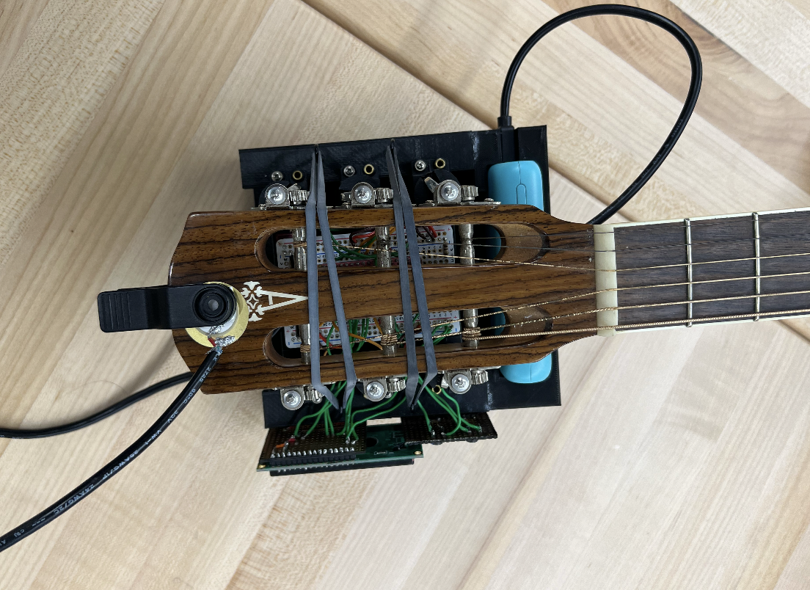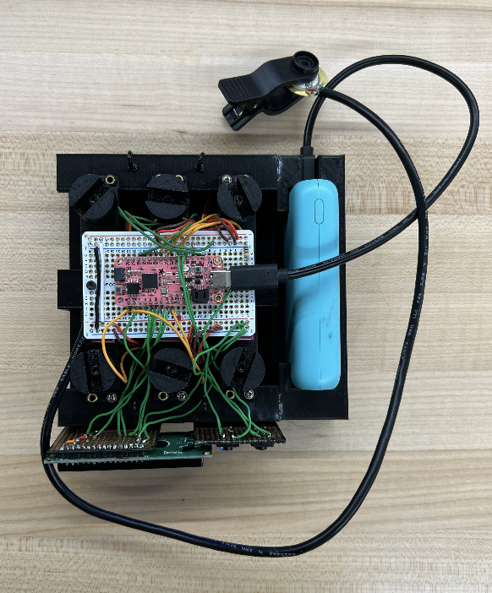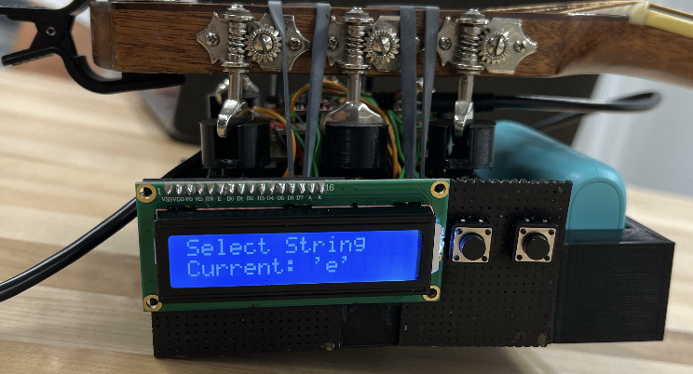

Figure 1: Two top down views of the completed Production Release. Side view of the device secured using two sets of hooks and bands, with the motor tuning attachment properly fitting onto the guitar’s tuning pegs.

User Experience

**Interface/Navigation**

The user will be interfacing with the LCD screen and two push buttons as a means of interacting with the tuner. The push buttons will be accessible to the user to the right of the LCD screen. The “next” button on the left allows the user to scroll through the 6 string selection options at the beginning of the tuning process. The LCD screen has the bottom string of the guitar (the low ‘E’) automatically selected as the default at the start of the program. As the next button is pressed, the LCD screen will update with the newly selected string. The select button to the right will accurately detect when a selection is made by the user, and the LCD will display the correct string that was selected. The LCD will then instruct the user when to strum the relevant string and, while data is being collected from the strum, will inform the user of the number of samples taken. When the measured frequency isn’t close to the target frequency within an acceptable range the motors will move the tuning peg as expected and the user is prompted to strum the guitar string again. When the string is determined to be in tune, the user will be notified on the LCD that the string is 100% in tune, and the program will reset to allow for another string selection. To quit tuning in the middle of the tuning process to switch strings, the user can press the select button again and the program will reset automatically. To turn the tuner on/off, the user can press the power button on the top of the battery pack.

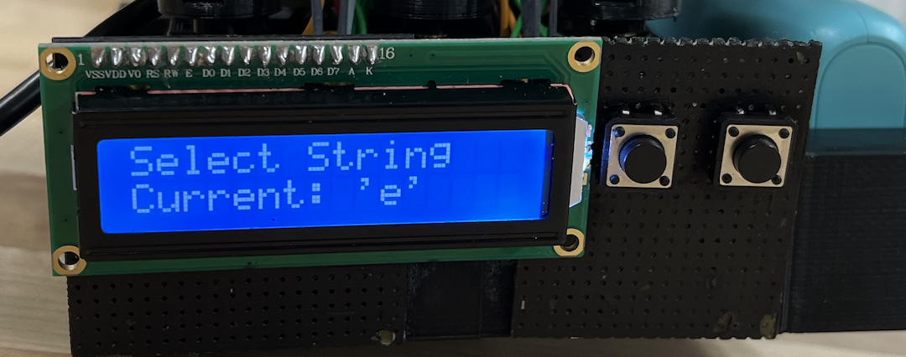

Figure 2: User is first prompted to select a string.

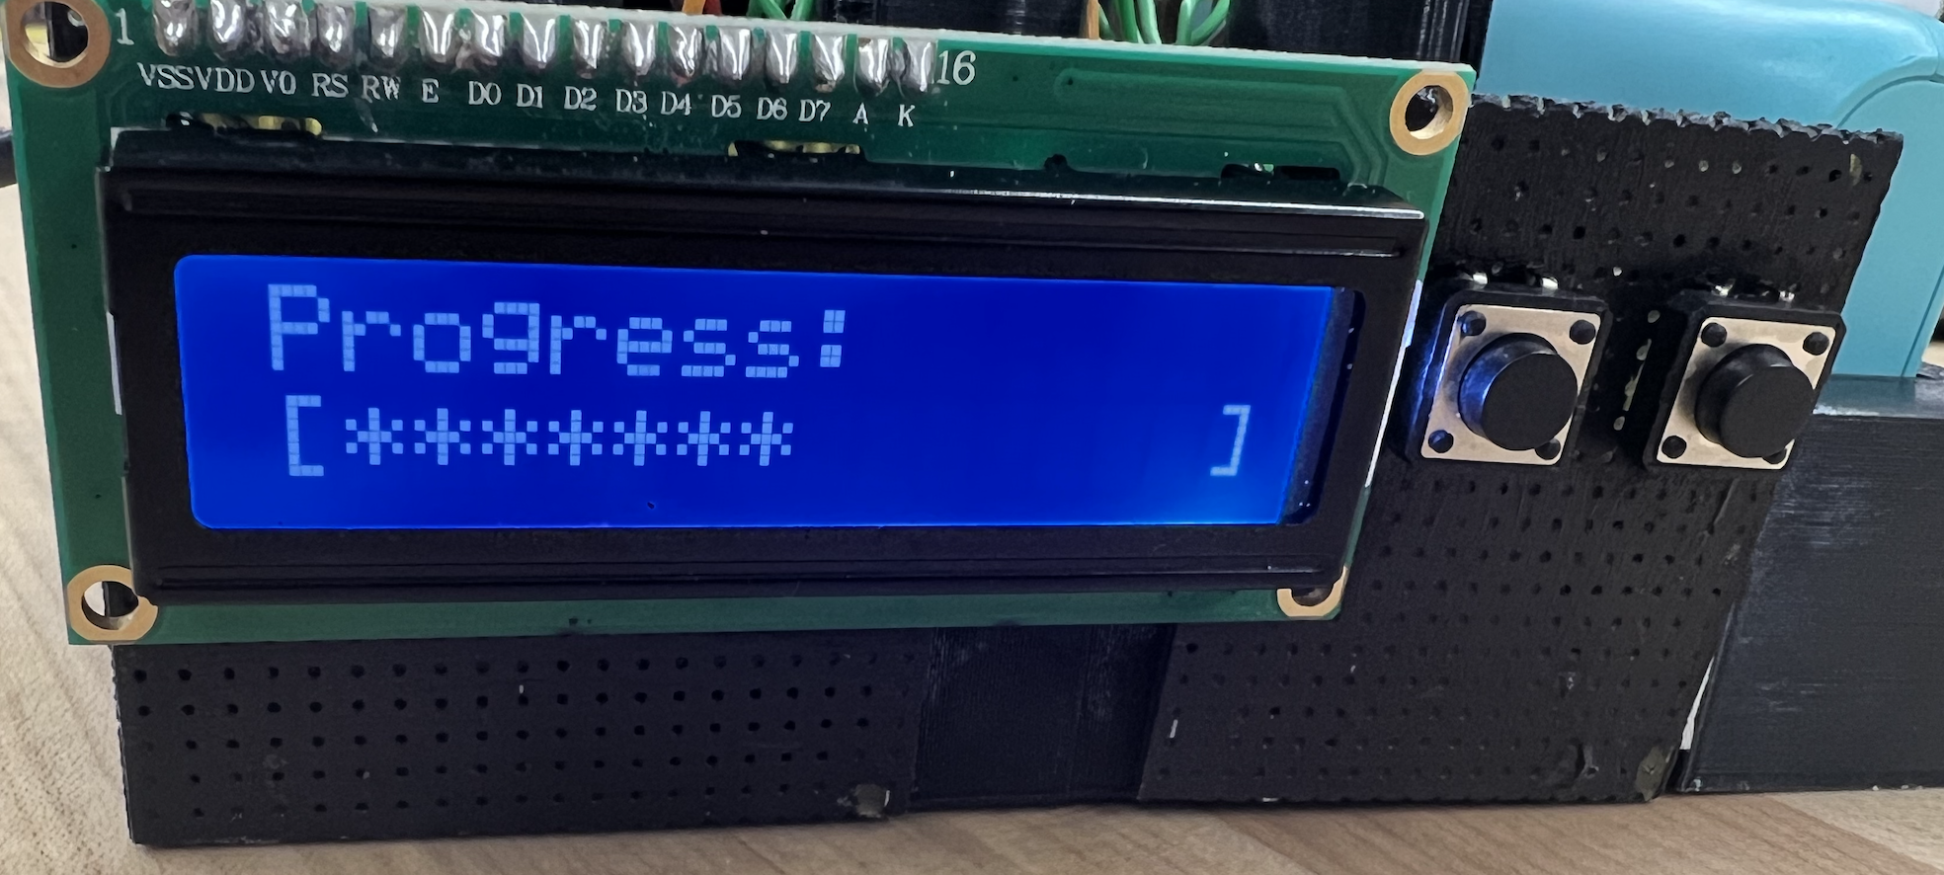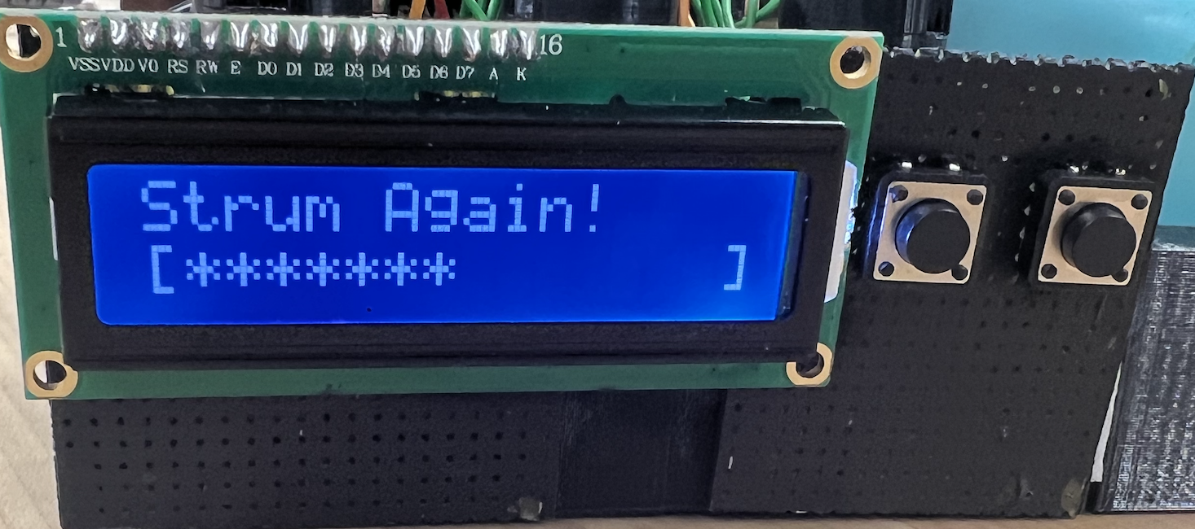

Figure 3: Percentage of how tuned the selected string is. This is displayed after the frequency is measured. Once the progress is shown, the user is then prompted to strum the selected string again.

**Perception**

The device’s LCD interface will be facing upright, directly displaying information to the user as they hold the guitar normally. Buttons are readily available for them to select a string to tune and the selection is clearly displayed for the user. When the device is powered on, the user is greeted with a welcome prompt and is told to select a string. Once a button confirms the string selection, the LCD prompts the user to strum the selected string. When the device has received enough samples to assess the state of the string, the relevant tuning peg is adjusted by the servo motors as needed. Meanwhile, the overall tuning progress is displayed to the user, as shown in Figure 3, and later prompts the user to strum the selected string again if the tuning has not yet been completed. Because the product automatically tunes the guitar, the majority of the tuning process is hands-off for users. The only parts of the process that require user intervention are explicit, seamless, and allow user navigation into and out of the various steps of the process as desired.

**Responsiveness**

The device’s buttons are debounced via software, allowing for immediate responsiveness and avoidance of false button inputs. Additionally, the vibration of the guitar strings only needs to be measured for a short period of time to obtain enough samples before the device detects whether or not it is tuned. The overall program runs without delay or unpredictable glitches and the user is able to intuitively use the device without additional assistance. Furthermore, once the device commences the tuning process, the user has the ability to restart the program at any point. Resetting the device does not interrupt its functionality but instead immediately restarts the tuning process, allowing the user to tune another string.

Build Quality

**Robustness/Consistency**

When running the program normally, the device is able to run through menu options, update the tuning progress bar, and turn the motors without any crashing or system failures. There are multiple filters in-place, both in hardware and software, to ensure that the system does not pick up unwanted frequencies and produce undesired results such as improper tuning. When the second harmonic of the strings appears more strongly at the input than its fundamental frequency, our code has the infrastructure in place to account for the doubled frequencies. All random instances of crashes have been debugged and dealt with as well, creating a smooth and consistent user experience. Furthermore, the responsiveness of the buttons is immediate, without bouncing or false input detections, and accurately selects the string to be tuned.

The measured frequencies remain consistent as we have the signal fed through a charge amplifier and a Schmitt Trigger. The charge amplifier makes the resultant sine wave reflect the vibration of the guitar more accurately because the piezo produces a proportional charge to mechanical stress, not a proportional voltage. The charge amplifier also nulls the effects the piezo sensor and its cable’s internal capacitance could potentially have on our signal. The charge amplifier eliminates noise by only allowing frequencies within the guitar’s expected operating range (~60-360Hz) to continue through the circuitry. The Schmitt Trigger can produce a clean and accurate square wave representation from potentially noisy sinusoidal signals via its two threshold voltages.

**Aesthetic Rigor**

The device and all of its components are securely attached to a custom design 3D-printed enclosure. Both the motors and perf-boards are securely screwed into the enclosure and do not move around at all. The LCD display and control buttons are adhered to the side of the enclosure ensuring stability while also allowing users to control the device and clearly read the LCD display. While holding the guitar normally, the user is able to clearly see the information displayed on the LCD. The battery pack has its own 3D-printed enclosure that is also adhered to another side of the main enclosure. The battery can be easily charged on the side of the device and can be removed and replaced if ever needed. The piezo sensor is connected to the circuitry of the device via a wire and is attached to a clip that can be easily put on the head of the guitar. Although circuitry and other mechanical components are exposed to the user, they do not detract from the overall appearance or functionality of the device as they are tucked away and deliberately placed.

Features

**External Interface**

Our automatic guitar tuner’s external interface consists of a piezo vibration sensor that clips to the headstock of a guitar, 6 servo motors whose attachments line up with the tuning pegs of a guitar, 2 buttons that are available for input from the user, an LCD that outputs information to the user, and a rechargeable battery that powers the tuner. The piezo sensor sends the electrical representation of the guitar vibrations to the Adafruit RP2040 microcontroller via some signal conditioning circuitry. The circuitry amplifies the signal while attenuating frequencies outside of the 60Hz-360Hz range that we have decided on to be the operating range of the guitar tuner. The circuitry also converts the potentially noisy sine wave from the amplifier into a clean square wave representation. The buttons send user decisions on what they want the tuner to do to the microcontroller. The LCD informs users of any actions they need to take, the status of the tuning, and any options they have while tuning. The battery allows users to turn the tuner on/off and recharge the tuner. All elements of the external interface connect to the persistent state within the microcontroller via its ports/pins. Connections between the external interface and the microcontroller are soldered, permanent, and require no action from the user to set up. With access to the external interface, users have complete control over the guitar tuner and can put all events relevant to using the tuner into motion.

**Persistent State**

The guitar tuner stores its data via state variables and constants in memory. The constants are stored in onboard flash memory and are necessary for our internal tuning systems to run properly. The state variables are stored in RAM on the Adafruit board and are updated in response to input from our external interface. For instance, state variables relevant to the string that is selected by users via the buttons/LCD are automatically set by internal systems. In addition, the data from our vibration sensing circuitry is polled and processed by our internal systems when appropriate. The persistent state stores this information to determine if the motors from our external interface need to turn the tuning pegs on the guitar or if the user needs to be informed of a change in the state of the system. The persistent state connects to the external interface of our build through pins on the RP2040 microcontroller.. The persistent state connects to the internal systems because the internal systems on the microcontroller have direct access to the variables and constants they require to operate.

**Internal Systems**

Our three main internal systems are our frequency-detection system to determine the tuning of the guitar, our motor-turning system to alter the tuning of the guitar, and our UI system to allow users to interface with our guitar tuner. The data processing for each system is fully implemented and automatically occurs in response to events from the external interface. The UI system is polled at the beginning of the event loop of our tuner to determine what string the user wants to tune. User input from the next and select buttons is received via their pins on the microcontroller and automatically updates the state variables of the persistent state.

When the user strums the relevant guitar string at the proper stage of execution, the frequency detection system samples the inputted square wave via the relevant microcontroller pin. The frequency detection system uses multiple sampled periods of the square wave from the guitar to perform an accurate frequency calculation. If the wrong string is strummed or other vibrations are picked up by the sensor during this period, the frequency detection system ignores the data it receives. All of the checks, statistics, and averaging that occurs during this process makes the frequency detection system impervious to faulty data because this system only reports its frequency calculation to other systems if the value was obtained from multiple precise samples within a specified range. When a valid frequency is calculated, the frequency is reported to the motor turning system and UI system to progress with the tuning via state variables in the persistent state.

The motor turning system turns the relevant motor a specified amount and in a specified direction based on the frequency’s relation to its desired value. This system turns motors for a longer or shorter duration based on the frequency being farther or closer to its goal value. The motor turning system allows for speed and accuracy of within 0.5Hz while tuning the guitar strings. The motor turning system interfaces with the external motors via pins on the microcontroller. This system has the pin that corresponds to each string hard-coded as a constant in memory so as to not allow for the turning of other motors than the string being tuned.